1. Estimating Gas Initially In Place (GIIP)
The GIIP is calculated using the volumetric formula:
$$GIIP=\frac{GRV×N/G×ϕ×\left(1-S_{wi}\right)}{B_{gi}}$$
- Gross Rock Volume (GRV): Use Figures 1 and 2 (Top and Base Bajocian maps) to perform area-depth integration. Determine the Gas-Water Contact (GWC) by checking Well 15/9-A (water-bearing) versus 15/9-B and 15/9-C (gas-bearing). The GWC likely lies between the deepest gas and shallow
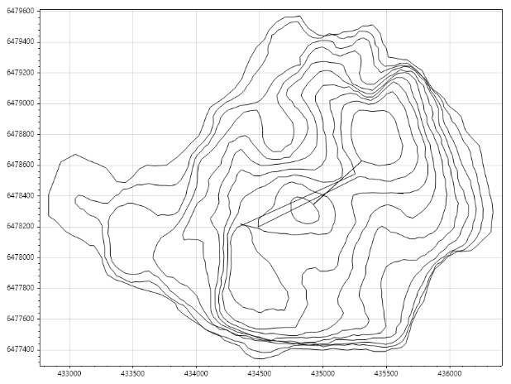
Figure 1: Top Map Contour above 3100
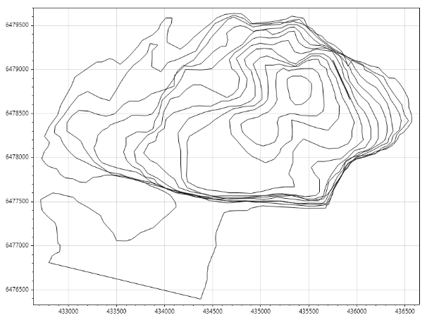
Figure 2: Base Map Contour above 3100

Area and Depth from contour
Level = 2825, Area = 66384.25  Level = 2850, Area = 358195.97  Level = 2875, Area = 588982.54  Level = 2900, Area = 1031353.65  Level = 2925, Area = 1014843.64  Level = 2950, Area = 1070644.33 | Level = 2975, Area = 1065063.00  Level = 3000, Area = 1007637.57  Level = 3025, Area = 961897.75  Level = 3050, Area = 906712.69  Level = 3075, Area = 944276.82  Level = 3100, Area = 2491628.00

GRV = $\int_{3100}^{2825}{A(z)dz}$= 2.576e8 m³

- Petrophysics ($N/G,ϕ,S_{wi}$): From the petrophysical sums and capillary pressure sheets, determine the average Net-to-Gross, porosity, and initial water saturation. Use the different cut-offs provided to establish Low, Mid, and High cases.
Using the petrophysics data,
$μ_{NTG}$= 0.879, $σ_{NTG}$= 0.1179, $μ_{ϕ}$= 0.204, $σ_{ϕ}$= 0.027;
Reservoir Pressure is around 300bars and Temperature = 363K
$$B_{g}=0.00347⋅\frac{Z⋅T}{P}$$
$$B_{gi} = 0.00347⋅\frac{0.95⋅363}{300} = 0.00399 m^{3}/m^{3}$$
At that point, variation of saturation with depth can be computed using the difference in gas and water hydrostatic pressure.
$$∆P=g∆z\left(ρ_{w}-ρ_{g}\right)$$
At the reservoir level,
$$ρ_{g}=\frac{ρ_{gs}∙T_{s}∙P_{r}}{T_{r}∙P_{s}∙Z}=335.2kg/m^{3}$$
With that we compute Saturation at all levels
Level = 2825, Saturation = 0.2128  Level = 2850, Saturation = 0.2247  Level = 2875, Saturation = 0.2367  Level = 2900, Saturation = 0.2486  Level = 2925, Saturation = 0.2605  Level = 2950, Saturation = 0.2724 | Level = 2975, Saturation = 0.2923  Level = 3000, Saturation = 0.3353  Level = 3025, Saturation = 0.3970  Level = 3050, Saturation = 0.4967  Level = 3075, Saturation = 0.7119  Level = 3100, Saturation = 1.0000

$$Swavg = \frac{\int_{3100}^{2825}{Sw(z)A(z)dz}}{\int_{3100}^{2825}{A(z)dz}} = 0.4946$$
Area weighted average saturation = 0.4946
Hence, we can compute the high mid and low cases of these parameters assuming normal distribution.
 | High ($μ- 1.282σ$) | Mid ($μ$) | Low ($μ+ 1.282σ$)
NTG | 0.728 | 0.879 | 1.000
$$ϕ$$ | 0.169 | 0.204 | 0.239
$$S_{wi}$$ | 0.4946 | 0.4946 | 0.4946
GIIP | 4.12e9 | 6.00e9 | 8.22e9

2. Initial Well Production Rate and Well Count
- Well Inflow Performance (IPR): Use the 15/9-C well test data to plot a back-pressure curve ($q$ vs. $ΔP^{2}$) or determine the Productivity Index ($PI$).
$$Q = C{\left(P_{r}^{2} - P_{wf}^{2}\right)}^{n}, C = 2036.82, n = 0.5610$$
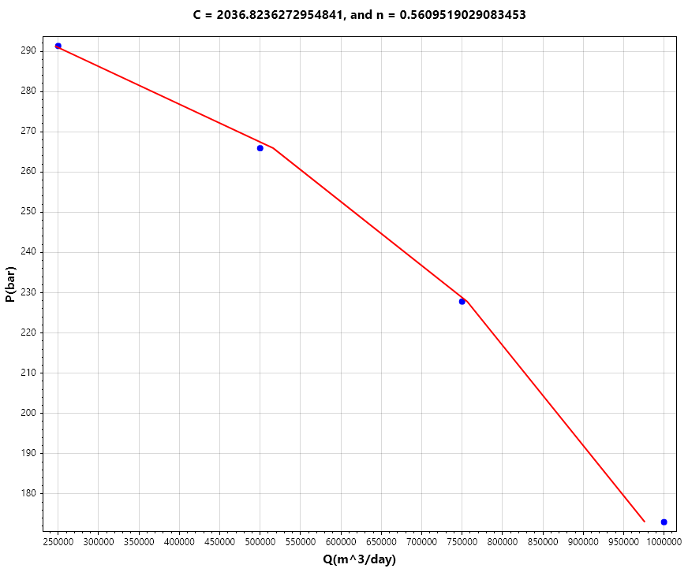
Figure 3: Well Test Data Analysis. C = 2036, n = 0.5610

- Nodal Analysis: Intersect the IPR with the VFP (Vertical Flow Performance) curves from the Excel file at the initial FTHP of 100 bara. This gives the maximum initial rate per well.
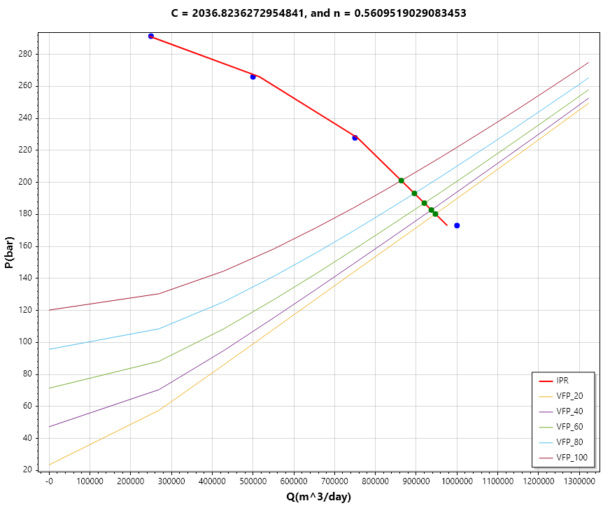
Figure 4: Nodal Analysis (IPR + VFP)
For all the THP provided in the data, the draw down would exceed 100 bara for a single well.
Here is the table of drawdown for each scenario
THP(Bara) | Q(m^3) | Pwf (Bara) | Drawdown(Bar)
100 | 863478.93 | 201.09 | 98.91
80 | 895652.77 | 193.07 | 106.93
60 | 920025.29 | 187.00 | 113.00
40 | 937180.63 | 182.73 | 117.27
20 | 947179.17 | 180.24 | 119.76

- Sand Control Constraint: Ensure the drawdown does not exceed the 100 bar limit mentioned in the geo-mechanical data.
For all the THP provided in the data, the drawdown for 2 wells would not exceed 100 bar as shown below
THP(Bara) | Q(m^3) | Pwf (Bara) | Drawdown(Bar)
100 | 1193570.09 | 253.12 | 46.88
80 | 1234462.32 | 249.87 | 50.13
60 | 1264990.91 | 247.45 | 52.55
40 | 1286012.36 | 245.78 | 54.22
20 | 1298076.44 | 244.83 | 55.17

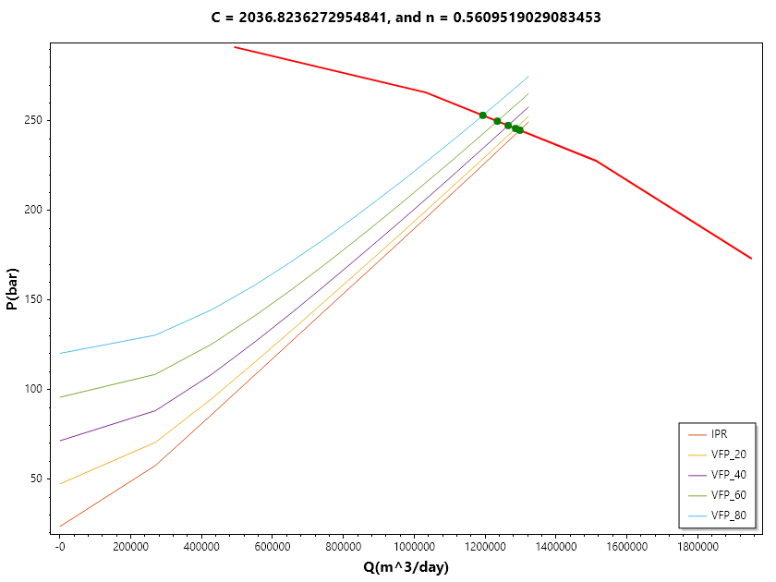
Figure 5: Nodal Analysis showing flowing rate for 2 wells at different THP
3. Recovery Factor (RF) and Ultimate Recovery (UR)
- Recovery Factor:
  - Analogue Approach: Use the Merlin field production data provided in the Excel file to estimate RF.
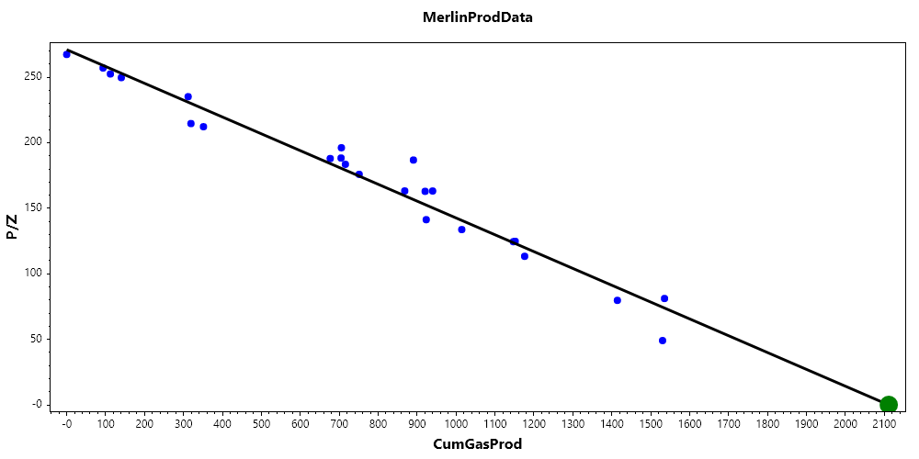
Merlin GIIP $=2111.40Mm^{3}$
This shows Merlin has an $RF = 1535.45/ 2111.40 = 0.7272$
  - Analytical Approach: Use the PVT data to determine the abandonment pressure. Since the field has three compression stages (100, 60, and 20 bara), the RF will increase as the abandonment pressure decreases.
Since abandonment rate is 0.2Mm^3/day, from 20bara vfp,
we got P_wf = 48.81 bara.
Hence we now compute the reservoir Pressure using the well test data.
$$P_{r} =\sqrt{P_{wf}^{2}+{\left(\frac{Q}{C}\right)}^{1/n}}= 77.07bara$$
Assuming that like Merlin, Morgana will also undergo volumetric depletion,
$$RF = 1 - \frac{P_{i}/Z_{i}}{P_{a}/Z_{a}} = 0.7337$$
- Ultimate Recovery: $UR = GIIP \times RF$. Calculate this for the Low, Mid, and High GIIP scenarios.
 | High ($μ- 1.282σ$) | Mid ($μ$) | Low ($μ+ 1.282σ$)
NTG | 0.728 | 0.879 | 1.000
$$ϕ$$ | 0.169 | 0.204 | 0.239
$$S_{wi}$$ | 0.4946 | 0.4946 | 0.4946
GIIP | 4.12e9 | 6.00e9 | 8.22e9
UR | 3.06e9 | 4.45e9 | 6.10e9

4. Production Profiles and Reserves
The optimum development scenario that maximises the field production rate while honouring a post-plateau decline rate of 0.3 yr⁻¹ consists of two production wells.
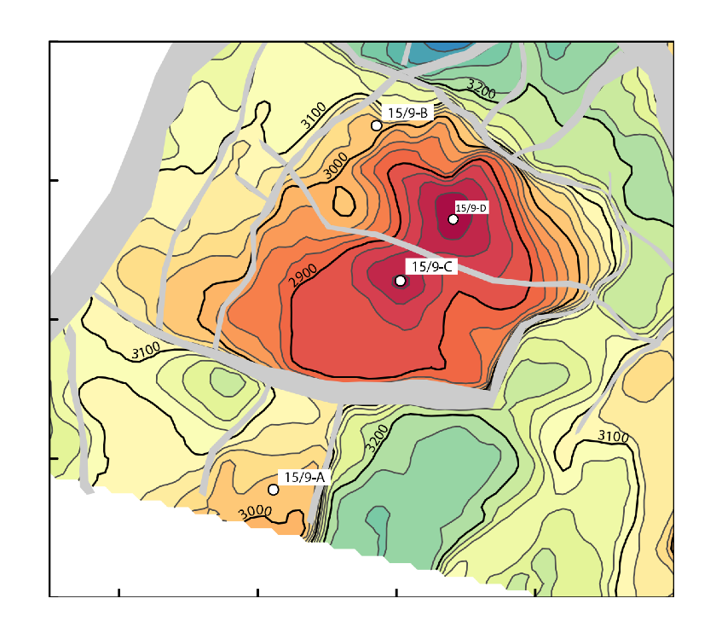
Figure 6: Showing development well(15/9-D), indicating two wells(15/9-C and 15/9-D) as the optimum case.
This was obtained using a simple pressure simulator and IPR equation derived from the well test data and the VFP data.
Based on the top structure map, the two development wells should be positioned crestally within zones of high gas saturation, as shown in Figure 2. Such crestal placement ensures early gas breakthrough and maximised recovery efficiency.

5. What is the Range of Production Profiles ?
Following the successful drilling of the discovery well 15/9-B, an appraisal well, 15/9-C, was subsequently drilled. Given that well 15/9-B was drilled in 2010, the spud year for well 15/9-C was also assumed to be 2010. The well test rate for the appraisal well was 1.0 Msm³/d.
The field production scheduled, assuming instant ramp-up to plateau, was modelled and is presented in Figure 3.
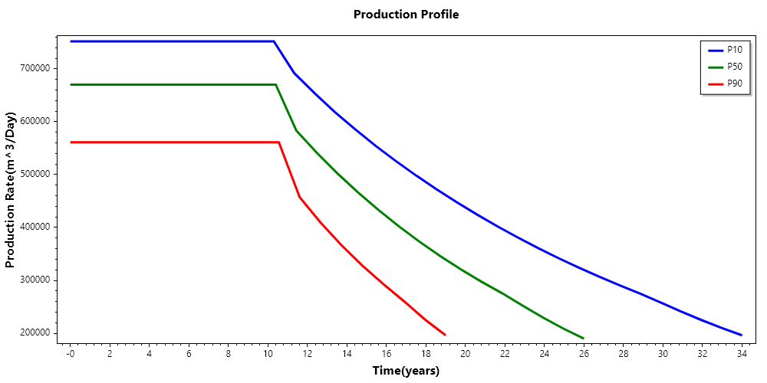
Figure 7: Field production schedule generated in showing plateau production.
From the production forecast table shown in Figure 7, shows the plateau production rate of 0.8, 0.68 and 0.55 Msm³/d for the Low, Mid, High. At this rates, the plateau production condition would be respected for the first 10 years and the decline rate after that would be less than 0.3/year.
A post-plateau decline rate of 0.3 yr⁻¹ was applied using a hyperbolic decline model to forecast gas production until an abandonment rate of 0.2 Msm³/d, as shown in Figure 4. The decline phase extends over approximately 11 years.

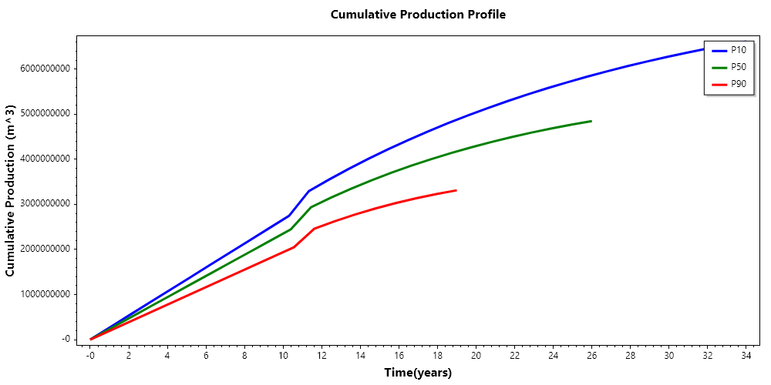
Figure 8: Cumulative Gas Production
Figure 8 shows the EUR for Low, Mid and High as 6.1e9, 4.45e9 and 3.06e9, respectively.
Average condensate production rates and cumulative condensate volumes are summarised in the table presented in Figure 5, while the production trend is clearly illustrated in the corresponding performance plot
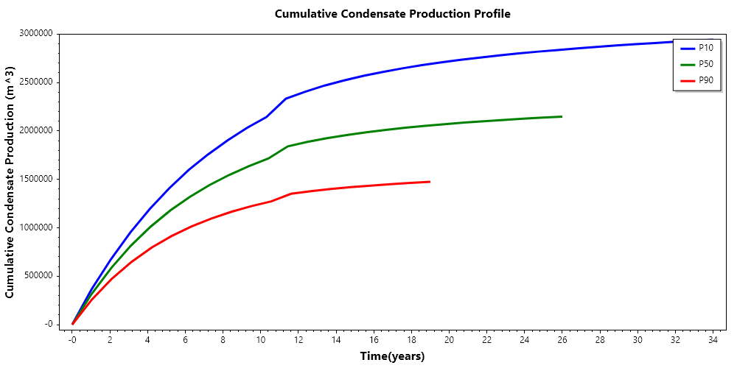
Figure 9: cumulative condensate production with associated production trend for the Morgana Field

High
Time(Years) | ProdRate(Mm^3) | Thp(bar) | CumGasProd(Mm^3) | CumCondProd(Mm^3)
$$0$$ | $$0.561$$ | $$100$$ | $$0$$ | $$0$$
$$1$$ | $$0.561$$ | $$100$$ | $$204.7655$$ | $$0.261$$
$$2$$ | $$0.561$$ | $$100$$ | $$409.531$$ | $$0.4746$$
$$3$$ | $$0.561$$ | $$100$$ | $$614.2965$$ | $$0.6507$$
$$4$$ | $$0.561$$ | $$100$$ | $$819.0621$$ | $$0.796$$
$$5$$ | $$0.561$$ | $$100$$ | $$1023.8276$$ | $$0.9153$$
$$6$$ | $$0.561$$ | $$100$$ | $$1228.5931$$ | $$1.0141$$
$$7$$ | $$0.561$$ | $$100$$ | $$1433.3586$$ | $$1.0962$$
$$8$$ | $$0.561$$ | $$60$$ | $$1638.1241$$ | $$1.1648$$
$$9$$ | $$0.561$$ | $$60$$ | $$1842.8896$$ | $$1.2229$$
$$10$$ | $$0.561$$ | $$20$$ | $$2047.6552$$ | $$1.272$$
$$11$$ | $$0.4573$$ | $$20$$ | $$2457.1862$$ | $$1.351$$
$$12$$ | $$0.4095$$ | $$20$$ | $$2624.0827$$ | $$1.3781$$
$$13$$ | $$0.3666$$ | $$20$$ | $$2773.566$$ | $$1.4002$$
$$14$$ | $$0.3281$$ | $$20$$ | $$2907.3727$$ | $$1.419$$
$$15$$ | $$0.2934$$ | $$20$$ | $$3027.1123$$ | $$1.4356$$
$$16$$ | $$0.2606$$ | $$20$$ | $$3134.1954$$ | $$1.4498$$
$$17$$ | $$0.2262$$ | $$20$$ | $$3229.306$$ | $$1.4627$$
$$18$$ | $$0.1962$$ | $$20$$ | $$3311.8575$$ | $$1.4739$$

Mid
Time(Years) | ProdRate(Mm^3) | Thp(bar) | CumGasProd(Mm^3) | CumCondProd(Mm^3)
$$0$$ | $$0.6702$$ | $$100$$ | $$0$$ | $$0$$
$$1$$ | $$0.6702$$ | $$100$$ | $$244.6307$$ | $$0.3191$$
$$2$$ | $$0.6702$$ | $$100$$ | $$489.2613$$ | $$0.5864$$
$$3$$ | $$0.6702$$ | $$100$$ | $$733.892$$ | $$0.8163$$
$$4$$ | $$0.6702$$ | $$100$$ | $$978.5226$$ | $$1.0113$$
$$5$$ | $$0.6702$$ | $$100$$ | $$1223.1533$$ | $$1.1785$$
$$6$$ | $$0.6702$$ | $$100$$ | $$1467.7839$$ | $$1.3198$$
$$7$$ | $$0.6702$$ | $$100$$ | $$1712.4146$$ | $$1.4406$$
$$8$$ | $$0.6702$$ | $$60$$ | $$1957.0452$$ | $$1.5449$$
$$9$$ | $$0.6702$$ | $$60$$ | $$2201.6759$$ | $$1.6354$$
$$10$$ | $$0.6702$$ | $$20$$ | $$2446.3065$$ | $$1.7144$$
$$11$$ | $$0.5834$$ | $$20$$ | $$2935.5678$$ | $$1.8411$$
$$12$$ | $$0.5411$$ | $$20$$ | $$3148.4917$$ | $$1.8874$$
$$13$$ | $$0.5023$$ | $$20$$ | $$3345.986$$ | $$1.9256$$
$$14$$ | $$0.4664$$ | $$20$$ | $$3529.3137$$ | $$1.9583$$
$$15$$ | $$0.4331$$ | $$20$$ | $$3699.5381$$ | $$1.9867$$
$$16$$ | $$0.4019$$ | $$20$$ | $$3857.615$$ | $$2.0113$$
$$17$$ | $$0.373$$ | $$20$$ | $$4004.3237$$ | $$2.033$$
$$18$$ | $$0.346$$ | $$20$$ | $$4140.4589$$ | $$2.0528$$
$$19$$ | $$0.321$$ | $$20$$ | $$4266.7425$$ | $$2.07$$
$$20$$ | $$0.2977$$ | $$20$$ | $$4383.913$$ | $$2.0862$$
$$21$$ | $$0.276$$ | $$20$$ | $$4492.5701$$ | $$2.101$$
$$22$$ | $$0.2526$$ | $$20$$ | $$4593.316$$ | $$2.1142$$
$$23$$ | $$0.2297$$ | $$20$$ | $$4685.5327$$ | $$2.1267$$
$$24$$ | $$0.2088$$ | $$20$$ | $$4769.3786$$ | $$2.1384$$
$$25$$ | $$0.1898$$ | $$20$$ | $$4845.5827$$ | $$2.1485$$

Low
Time(Years) | ProdRate(Mm^3) | Thp(bar) | CumGasProd(Mm^3) | CumCondProd(Mm^3)
$$0$$ | $$0.752$$ | $$100$$ | $$0$$ | $$0$$
$$1$$ | $$0.752$$ | $$100$$ | $$274.4903$$ | $$0.3646$$
$$2$$ | $$0.752$$ | $$100$$ | $$548.9807$$ | $$0.6767$$
$$3$$ | $$0.752$$ | $$100$$ | $$823.471$$ | $$0.9531$$
$$4$$ | $$0.752$$ | $$100$$ | $$1097.9614$$ | $$1.1953$$
$$5$$ | $$0.752$$ | $$100$$ | $$1372.4517$$ | $$1.4085$$
$$6$$ | $$0.752$$ | $$100$$ | $$1646.9421$$ | $$1.5969$$
$$7$$ | $$0.752$$ | $$100$$ | $$1921.4324$$ | $$1.7585$$
$$8$$ | $$0.752$$ | $$60$$ | $$2195.9228$$ | $$1.9026$$
$$9$$ | $$0.752$$ | $$60$$ | $$2470.4131$$ | $$2.032$$
$$10$$ | $$0.752$$ | $$20$$ | $$2744.9035$$ | $$2.1428$$
$$11$$ | $$0.692$$ | $$20$$ | $$3293.8842$$ | $$2.3326$$
$$12$$ | $$0.654$$ | $$20$$ | $$3546.4483$$ | $$2.4048$$
$$13$$ | $$0.6183$$ | $$20$$ | $$3785.1604$$ | $$2.4693$$
$$14$$ | $$0.5855$$ | $$20$$ | $$4010.8321$$ | $$2.5215$$
$$15$$ | $$0.5545$$ | $$20$$ | $$4224.5528$$ | $$2.5696$$
$$16$$ | $$0.5255$$ | $$20$$ | $$4426.9278$$ | $$2.6096$$
$$17$$ | $$0.498$$ | $$20$$ | $$4618.7265$$ | $$2.6465$$
$$18$$ | $$0.472$$ | $$20$$ | $$4800.4795$$ | $$2.679$$
$$19$$ | $$0.4475$$ | $$20$$ | $$4972.7592$$ | $$2.7078$$
$$20$$ | $$0.4241$$ | $$20$$ | $$5136.0914$$ | $$2.7349$$
$$21$$ | $$0.4019$$ | $$20$$ | $$5290.8876$$ | $$2.7584$$
$$22$$ | $$0.3808$$ | $$20$$ | $$5437.5686$$ | $$2.7801$$
$$23$$ | $$0.3607$$ | $$20$$ | $$5576.5483$$ | $$2.8007$$
$$24$$ | $$0.3417$$ | $$20$$ | $$5708.1952$$ | $$2.8193$$
$$25$$ | $$0.3237$$ | $$20$$ | $$5832.908$$ | $$2.8363$$
$$26$$ | $$0.3066$$ | $$20$$ | $$5951.0568$$ | $$2.8526$$
$$27$$ | $$0.2903$$ | $$20$$ | $$6062.9561$$ | $$2.8682$$
$$28$$ | $$0.2749$$ | $$20$$ | $$6168.909$$ | $$2.8823$$
$$29$$ | $$0.2581$$ | $$20$$ | $$6269.2436$$ | $$2.8955$$
$$30$$ | $$0.241$$ | $$20$$ | $$6363.4445$$ | $$2.9081$$
$$31$$ | $$0.2251$$ | $$20$$ | $$6451.4205$$ | $$2.9201$$
$$32$$ | $$0.2101$$ | $$20$$ | $$6533.5643$$ | $$2.9315$$
$$33$$ | $$0.1961$$ | $$20$$ | $$6610.2475$$ | $$2.9418$$

